Principles of Design Notes
To provide an example in each box, you will insert a picture from the internet that illustrates each concept. DO NOT ADD PICTURES UNTIL TOLD TO DO SO.

Alignment  Every element in it is __visually _________ _____connected_________  to another element.  Example: 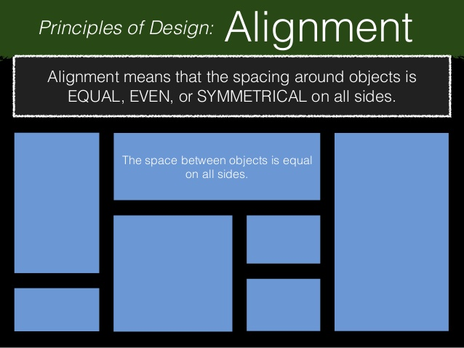 | Contrast  A difference created when __elements________ are placed ___next____ to ___each______ ____other_____.  Example: 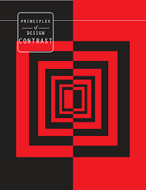
Repetition  The ___action_______ of ________repeating _________ something that has already been said or written  (aka):___rhythm___  Example: 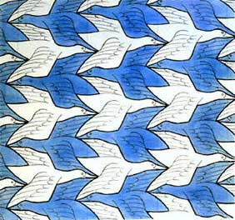 | Proximity  Proximity ______minimize_________ _____visual clutter_________ ___________, emphasizes organization and increases _____viewer__________ _________comprehension__________.  Example: 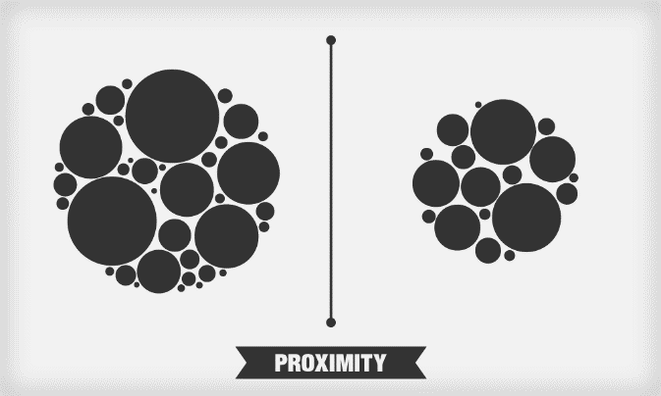
Proportion  ______comparative______ ______relationship________ between things or magnitudes as to ______size__, _____quantity_____, ____number______, etc.; ratio  Example: 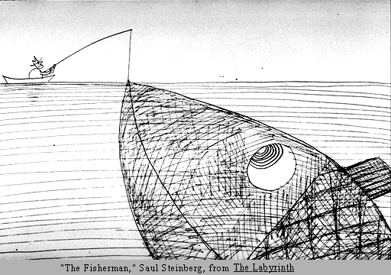 | Emphasis  is used to..  - Make an element or object ____stand_____ ____out____ in a work of art.  - Control what part of the artwork the viewer ______sees___ ______most_____ or most often  - Control how long a viewer spends looking at each of the _____diffrent_______ parts  Example: 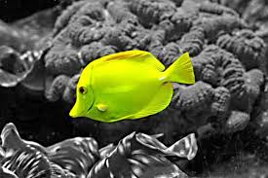
Balance
Formal Balance  Balance is formal when ___both_____ ___sides_____ are ____symetrical_________ in terms of arrangement.  Example:  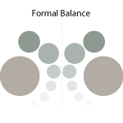 | Informal Balance  Balance is informal when sides aren’t__ ___exactly_____ ____symmetrical_________ but the resulting image is still balanced  Example:  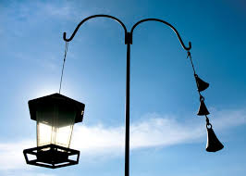
Unity  Unity or ___harmony______, is achieved in an art composition by using _____similer_____ elements throughout the work.  Example:  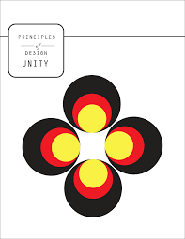 | Variety  is the quality or state of having ___diffrent_____ forms or types, notable _____ of _____contrast____, ______emphasis____, & ___diffrence_______in size and color.  Example:  